***Task 3.2***

**Step 2:**

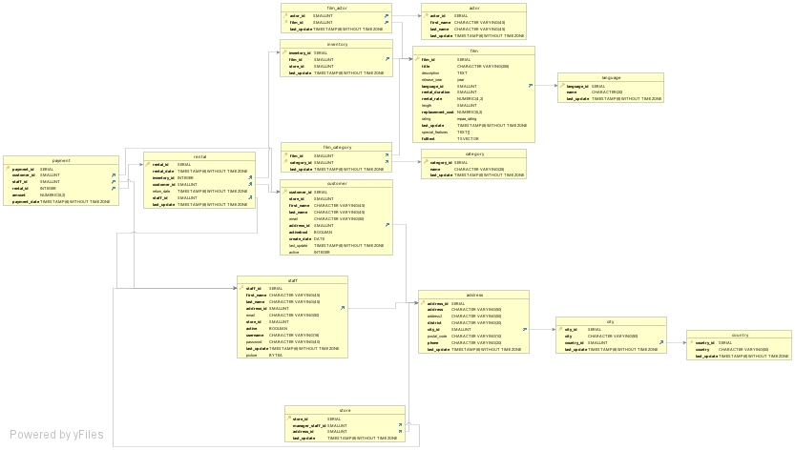

**Step 3:**

Rockbuster Database have a snowflake schema because the fact table rental and payment are surrounded by dimension table such as inventory and customer, then dimension tables are surrounded by subdimension table.

Fact tables and Dimension tables

Fact tables:

Rentals:

|  |  |  |
| --- | --- | --- |
| Column | Data Type | Description |
| Rental_id | Serial | Unique identifier for each rental transaction |
| Rental_date | Timestamp(6)without timezone | Data of rental occurred |
| Inventory_id | Integer | Unique identifier for inventory |
| Customer_id | Smallint | Unique identifier for customer |
| Return_date | Timestamp(6)without timezone | Date of item be returned |
| Staff_id | Smallint | Unique identifier for staff |
| Last_update | Timestamp(6)without timezone | Date and time of record last updated |

Payment

|  |  |  |
| --- | --- | --- |
| Column | Data Type | Description |
| Payment_id | Serial | Unique identifier of a payment |
| Customer_id | Smallint | Unique identifier of a customer |
| Staff_id | Smallint | Unique identifier of a staff member |
| Rental_id | Integer | Unique identifier of a rental |
| Amount | Numeric(5,2) | Price of the rental |
| Payment_date | Timestamp(6)without timezone | Date of the payment |

Dimension Tables

Customer

|  |  |  |
| --- | --- | --- |
| Column | Data Type | Description |
| Customer_id | Serial | Unique identifier of a customer |
| Store_id | Smallint | Unique identifier of a store |
| First_name | Character Varying(45) | First name of the customer |
| Last_name | Character Varying(45) | Last name of the customer |
| Email | Character Varying(50) | Email of the customer |
| Adress_id | Smallint | Adress of the customer |
| Activebool | Boolyan | Active or not |
| Create_date | Date | Data of being created |
| Last_update | Timestamp(6)without timezone | Date and time of record last updated |
| Active | Integer | Active or not |

Staff

|  |  |  |
| --- | --- | --- |
| Column | Data Type | Description |
| Staff_id | Serial | Unique identifier of a staff |
| Store_id | Smallint | Unique identifier of a store |
| First_name | Character Varying(45) | First name of the staff |
| Last_name | Character Varying(45) | Last name of the staff |
| Email | Character Varying(50) | Email of the staff |
| Adress_id | Smallint | Adress of the staff |
| Active | Boolyan | Active or not |
| User_name | Character Varying(16) | User_name of the staff |
| Password | Character Varying(40) | Password of the staff |
| Last_update | Timestamp(6)without timezone | Date and time of record last updated |
| Picture | Bytea | Photo of the staff |

Store

|  |  |  |
| --- | --- | --- |
| Column | Data Type | Description |
| Store_id | Serial | Unique identifier of a store |
| Manager_staff_id | Smallint | Unique identifier of the store manager |
| Adress_id | Smallint | Adress of the store |
| Last Update | Timestamp(6)without timezone | Date and time of record last updated |

Address

|  |  |  |
| --- | --- | --- |
| Column | Data Type | Description |
| Adress_id | Serial | Unique identifier of an address |
| Adress | Character Varying(50) | Adress details |
| Adress2 | Character Varying(50) | Extra address details |
| District | Character Varying(20) | Name of the district |
| City_id | Smallint | Unique identifier of a city |
| Postal_code | Character Varying(10) | Postal code details |
| Phone | Character Varying(20) | Postal code details |
| Last_update | Timestamp(6)without timezone | Date and time of record last updated |

City

|  |  |  |
| --- | --- | --- |
| Column | Data Type | Description |
| City_id | Serial | Unique identifier of a city |
| City | Character Varying(50) | Name of the city |
| Country_id | Smallint | Unique identifier of a country |
| Last_update | Timestamp(6)without timezone | Date and time of record last updated |

Country

|  |  |  |
| --- | --- | --- |
| Column | Data Type | Description |
| Country_id | Serial | Unique identifier of a country |
| Country | Character Varying(50) | Name of the country |
| Last_update | Timestamp(6)without timezone | Date and time of record last updated |

Film_Category

|  |  |  |
| --- | --- | --- |
| Column | Data Type | Description |
| Film_id | Smallint | Unique identifier of a film |
| Category_id | Smallint | Unique identifier of a category |
| Last_update | Timestamp(6)without timezone | Date and time of record last updated |

Category

|  |  |  |
| --- | --- | --- |
| Column | Data Type | Description |
| Category_id | Serial | Unique identifier of a category |
| Name | Character Varying (25) | Name of the category |
| Last_update | Character Varying (25) | Date and time of record last updated |

Inventory

|  |  |  |
| --- | --- | --- |
| Column | Data Type | Description |
| Inventory_id | Serial | Unique identifier of an inventory |
| Film_id | Smallint | Unique identifier of a film |
| Store_id | Smallint | Unique identifier of a store |
| Last_update | Timestamp(6)without timezone | Date and time of record last updated |

Film

|  |  |  |
| --- | --- | --- |
| Column | Data Type | Description |
| Film_id | Serial | Unique identifier of a film |
| Title | Character Varying(255) | Title of the movie |
| Description | TEXT | Description of the movie |
| Release_year | Year | Year that the movie came out |
| Language_id | Smallint | Unique identifier of the language |
| Rental_duration | Smallint | How long the movie has been rented |
| Rental_rate | Numeric(4,2) | Data of rental occurred |
| Length | Smallint | Duration of the movie |
| Replacement_cost | Numeric(5,2) | Costs to replace the rental movie |
| Rating | Mpaa_rating | Which age groups can watch the movie |
| Last_update | Timestamp(6)without timezone | Date and time of record last updated |
| Special_features | Text[] | Special features of the movie |
| Fulltext | TSVECTOR | Text of the movie |

Language

|  |  |  |
| --- | --- | --- |
| Column | Data Type | Description |
| Language_id | Serial | Unique identifier of the language |
| Name | Character (20) | Name of the language |
| Last_update | Timestamp(6)without timezone | Date and time of record last updated |

Film_actor

|  |  |  |
| --- | --- | --- |
| Column | Data Type | Description |
| Actor_id | Smallint | Unique identifier of the actor |
| Film_id | Smallint | Unique identifier of the film |
| Last_update | Timestamp(6)without timezone | Date and time of record last updated |

Actor

|  |  |  |
| --- | --- | --- |
| Column | Data Type | Description |
| Actor_id | Serial | Unique identifier of the actor |
| First_name | Character Varying(45) | First name of the actor |
| Last_name | Character Varying(45) | Last name of the actor |
| Last_update | Timestamp(6)without timezone | Date and time of record last updated |

**Step 4:**

Which actors brought Rockbuster the most revenue?

Rental – Payment – Inventory – Film_actor – Actor

What language are the majority of movies in the collection?

Inventory – Film - Language